
Week 2 Practical Tutorial
Planning a Secure Server Network
Server roles | simple network design | server placement | basic risk
Unit | J27P 35 - Server Administration for Cyber Security
SCQF level | 8
Scenario | Freeman Industries Secure Infrastructure Project
Scenario contact | David Freeman, IT Manager
Project namespace | corp.freemanindustries.com
Assessment link | Checkpoint 1 - Initial design proposal
SQA criteria | O1.1 and O1.2
Suggested duration | Approximately 2.5 to 3 hours
What you will produce
By the end of this tutorial you will have a first-draft Freeman Industries network design, a list of required server roles, a simple logical network diagram, two explained server-placement decisions and a small risk register. The completed tutorial itself will be your Week 2 evidence.

1. What this tutorial is about
This week is about planning. You are not installing Windows Server, configuring Active Directory, setting IP addresses or writing firewall rules yet. Those tasks come later.
The most important point
Your design does not have to be perfect. It is a sensible first draft that you will improve as you learn more. If you can explain why you placed a service somewhere, you are doing the right kind of work.

After completing this tutorial, you should be able to:
• identify the main services that Freeman Industries needs;
• explain, in simple terms, what common server roles do;
• separate public-facing services from internal services;
• draw a clear logical network diagram using ordinary boxes and arrows;
• give a simple security reason for a server-placement decision;
• identify three realistic risks and suggest a basic control for each.
2. What you are NOT expected to know yet
• Exact IP addresses or subnet masks.
• The commands used to install or configure server roles.
• Detailed firewall port numbers.
• Advanced Active Directory, DNS or DHCP configuration.
• High-availability or clustering designs.
• A final decision for every Windows Server edition or installation option.
Why the tutorial is structured this way
The SQA unit can be started without previous server-administration knowledge. This tutorial therefore introduces each term before asking you to use it.

3. Freeman Industries - the problem you are solving
Freeman Industries is replacing an inconsistent workgroup-based setup with a centrally managed Windows Server environment. The company currently has around 75 staff and expects to grow to about 100 staff.
The scenario identifies several existing problems. For this tutorial, concentrate on the following:
Current problem | Why it matters
Most computers use local accounts and passwords are inconsistent. | User access is difficult to control consistently.
A shared administrator account is used for routine support. | It is difficult to tell who made a change and too much privilege may be used.
The network is largely flat. | A compromised device may be able to reach systems it should not reach.
Files are spread across several computers. | Permissions, backup and recovery are harder to manage.
The public website is not consistently protected. | An internet-facing service needs stronger isolation and protection.

3.1 Task 1 - turn problems into requirements
A requirement is simply something the new network must be able to do. Read the scenario and write at least five requirements below.
Worked example
Problem: files are spread across several computers. Requirement: Freeman Industries needs centrally managed file storage with controlled access.

No. | Requirement for the new network | Why is it needed?
1 | [Type here] | [Type here]
2 | [Type here] | [Type here]
3 | [Type here] | [Type here]
4 | [Type here] | [Type here]
5 | [Type here] | [Type here]

4. Key words you need before drawing the network
You only need a small number of terms for this tutorial. Read this page before starting the design tasks.
Term | Plain-English meaning
Client | A user device, such as a Windows 11 PC, that connects to services provided by servers.
Server | A computer or virtual machine that provides a service to other computers.
Server role | The job a server performs. Examples include user authentication, DNS, DHCP, file storage or web hosting.
Internal network | The part of the network intended for staff and internal business systems rather than the general public.
Internet-facing service | A service that people on the internet need to reach, such as a public website.
Firewall | A security control that allows or blocks network traffic according to rules.
Network segment | A separated part of a network. Segmentation limits which systems can communicate directly.
DMZ / perimeter network | A separated area used for systems that must be reachable from the internet. It helps keep public-facing systems away from sensitive internal systems.
Attack surface | The parts of a system that an attacker could try to reach or misuse. Fewer exposed services usually means a smaller attack surface.

Do not worry about the letters DMZ
For this tutorial, think of a DMZ as a separate area for public-facing systems. You do not need to know the detailed firewall configuration yet.

5. The main server roles
A server role is simply a job performed by a server. Freeman Industries will need several roles as the project develops.
Role | What it does in simple terms | Who normally needs it?
Active Directory Domain Services (AD DS) | Stores and manages user accounts, computer accounts and central logon information. | Staff and IT - internal use
DNS | Helps computers find services by name instead of only by IP address. Active Directory relies heavily on DNS. | Staff, clients and servers - mainly internal
DHCP | Automatically gives client devices network settings such as an IP address. | Client devices - internal
File server | Stores shared folders and lets access be controlled centrally. | Staff - internal
Web server (IIS) | Hosts a website or web application. | Could be internal or public-facing, depending on the website

One server can have more than one role
In a small lab you may combine roles because hardware is limited. In a real design, putting every role on one server can increase the impact of a failure or compromise. Your diagram should show the logical separation that makes sense for the business.

6. Task 2 - create a simple server estate
A server estate is just a list of the servers or server roles that an organisation plans to use. Complete the table below. You are designing for the full Freeman Industries business, even though your practical lab may use fewer virtual machines.
Use the role table on the previous page. Suggested names are provided only to make the task easier; you may change them if your design uses a clear naming standard.
Suggested server name | Main role(s) | Internal or perimeter/DMZ? | One short reason
FI-DC01 | [Type here] | [Type here] | [Type here]
FI-FS01 | [Type here] | [Type here] | [Type here]
FI-WEB01 | [Type here] | [Type here] | [Type here]
FI-MGMT01 or other | [Type here] | [Type here] | [Type here]
Optional additional server | [Type here] | [Type here] | [Type here]

6.1 Simple placement rule
Ask one question
Does the general public on the internet need to reach this service? If NO, keep it on the internal network. If YES, consider a perimeter/DMZ area so the public-facing service is separated from sensitive internal services.

A domain controller or file server should not normally be directly exposed to the internet. A public website, however, must be reachable somehow, so it needs stronger separation and tightly controlled communication.
7. A simple way to think about server placement
The diagram below shows the idea of separating a public-facing service from internal services. It is an example of the concept only. It is not a completed Freeman Industries design.
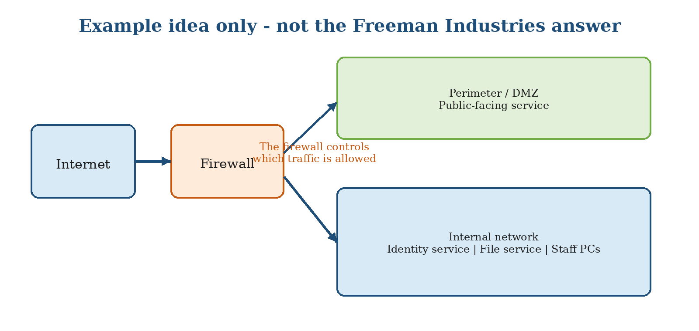
Notice three simple ideas:
- The public-facing service is not mixed directly with sensitive internal services.
- A firewall sits between networks and controls which communication is allowed.
- Internal identity, file and user systems remain on the internal network.
7.1 Physical placement and logical placement
Type of placement | What it means for this tutorial
Physical placement | Where the real hardware would be kept, for example in a locked server room rather than an open office.
Logical placement | Which network or security area the server belongs to, for example the internal network or a perimeter/DMZ network.

Your Week 2 diagram mainly shows logical placement. In your written explanation you can also mention that real servers should be physically protected from unauthorised access.

8. Task 3 - draw the Freeman Industries logical network
You can create the diagram directly in this document using Word shapes, or Cisco Packet Tracer and paste the finished image below. Do not worry about professional network symbols.
8.1 Step-by-step
- Create a box labelled Internet.
- Add a box labelled Firewall.
- Create one area labelled Perimeter / DMZ and one area labelled Internal Network.
- Place any public-facing service in the area you think is most appropriate.
- Place internal services such as identity, name resolution, addressing and file services in the area you think is most appropriate.
- Add a small group of Staff PCs / Clients to show where users connect.
- Use arrows to show the main communication paths. You do not need port numbers or IP addresses yet.
- Give the diagram a title: Freeman Industries - Initial Logical Network Design.
Keep the diagram simple
One clear page is better than a crowded enterprise diagram. The assessor needs to understand your main security zones, server roles and placement decisions.

Insert your logical network diagram here:
[Type your answer here]

9. Task 4 - explain two placement decisions
A good design is not just a picture. You must explain why you made important choices. Complete two explanations below in your own words.
Useful sentence starter
I placed the __________ service on the __________ network because __________. This reduces the risk of __________.

Decision | Your explanation
Placement decision 1 | [Type your explanation here]
Placement decision 2 | [Type your explanation here]

9.1 One more design question
Why is it safer to avoid placing a domain controller or file server directly on the public internet?
[Type your answer here]

10. Three security ideas: Confidentiality, Integrity and Availability
These three ideas are often called the CIA triad. You only need the simple meaning for this tutorial.
Security idea | Plain-English meaning | Freeman Industries example
Confidentiality | Only authorised people should be able to see information. | Finance and HR files should only be available to people who need them.
Integrity | Information and configurations should not be changed without authorisation. | A standard user should not be able to change important server settings.
Availability | Systems and data should be available when authorised users need them. | Staff should still be able to reach important services after a fault or recovery.

10.1 Your turn
Give one confidentiality example from your own design:
[Type your answer here]

Give one integrity example from your own design:
[Type your answer here]

Give one availability example from your own design:
[Type your answer here]

10.2 Reducing the attack surface
Attack surface means the parts of a system that an attacker could try to reach or misuse. Keeping internal servers away from the public internet, only enabling services that are needed and using separation can reduce the attack surface.
Give one way your Week 2 design reduces the attack surface:
[Type your answer here]

11. Task 5 - create a small risk register
A risk register is a simple record of things that could go wrong and what you plan to do about them. For this tutorial, choose three realistic risks from the Freeman Industries scenario.
Worked example
Problem: a former employee account remained active. What could happen: the old account could be misused. Basic control: use central account management and disable leavers promptly.

You may use problems such as the shared administrator account, flat network, insecure website, inconsistent file permissions, irregular backups or unapproved software.
Risk / problem | What could happen? | Basic control or design response
1. [Type here] | [Type here] | [Type here]
2. [Type here] | [Type here] | [Type here]
3. [Type here] | [Type here] | [Type here]

12. Checkpoint 1 - what must be complete
Before submitting Tutorial 02, check that the following evidence is inside this document. The completed tutorial is the Week 2 portfolio evidence; you do not need to create a separate weekly upload document.
□ At least five Freeman Industries requirements are completed in Task 1.
□ The server estate table identifies the main planned roles and where they will be placed.
□ A clear logical network diagram is inserted in Task 3.
□ Two server-placement decisions are explained in Task 4.
□ The confidentiality, integrity and availability questions are completed.
□ At least three risks and basic controls are recorded in Task 5.
□ Your answers are written in your own words and you can explain them if asked.
Evidence rule
A screenshot or diagram on its own is not enough. Under or beside your evidence, explain what it shows and why it supports your design decision.

12.1 File name and submission
Save the completed tutorial using the naming convention:
Surname_Firstname_Week_02.docx
Upload the completed document to the Tutorial 02 / Checkpoint 1 Moodle submission area. Keep the editable copy in your portfolio folder.
12.2 Final self-check
□ My diagram is readable and the main zones are labelled.
□ I have not included passwords, keys or real personal data.
□ I can explain why I placed my public-facing and internal services where I did.
□ I have saved the final version on my personal SSD / approved portfolio location.

13. Help if you get stuck
Use this page before assuming you have done something wrong. Week 2 is deliberately a first-draft design exercise.
If you are thinking... | Do this
“I do not know what goes in a DMZ.” | Put only services that need public internet access there. Keep sensitive internal services on the internal network.
“I do not know how many servers to draw.” | Show the roles the real business needs. The practical lab may use fewer VMs later because hardware is limited.
“I do not know the IP addresses.” | That is fine. IP addressing is covered later. Do not invent detailed addressing for this tutorial.
“I do not know which firewall ports to allow.” | That is also fine. Show the firewall and the main communication direction only.
“My diagram does not look professional.” | Use simple boxes, labels and arrows. Clear thinking matters more than specialised network symbols.
“My design is different from another student’s.” | More than one design can be acceptable. Your job is to make sensible choices and explain the security reason for them.

